Potato Chat Protocol

Team 2
December 2, 2019

Team Members
Karim Brusetti
Filippo De Iseppi
Andrea Beltrami
Nicolò De Giorgi
David Brazzarola

Contents

Contents 2
1 Project description 3
2 Client 3
3 Packets 5
4 Client program 5
5 Design 6

Project Description

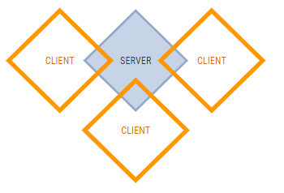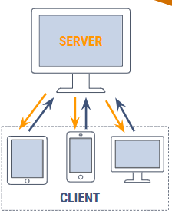

One server, multiple clients. All for a common purpose: building a 100% functional chat.

Packet Description

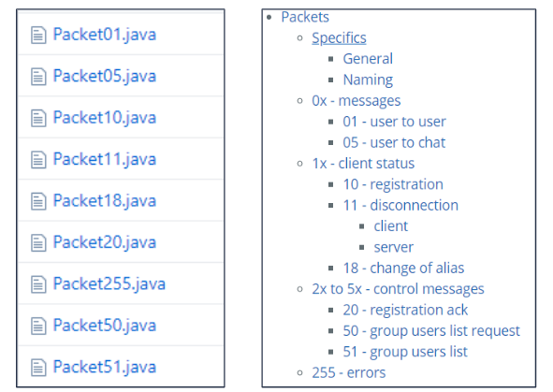

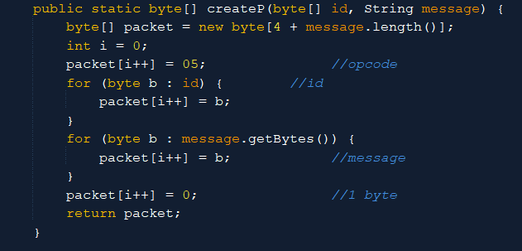

3 Client Program

Connection class = connection between client and server

Thread Interpreter = plays packet from server

Thread Listener = recive packet from server

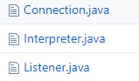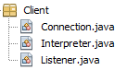

- Design

To create the graphic part we used Swing

